2018 Oregon Amend Instructions for the TurboTax Online product:

- To open your 2018 return, go to https://turbotax.intuit.com and sign in.

- On the Sign In screen, enter your User ID and Password and select Sign In.

- From the Tax home screen, scroll down and select Your tax returns & documents.
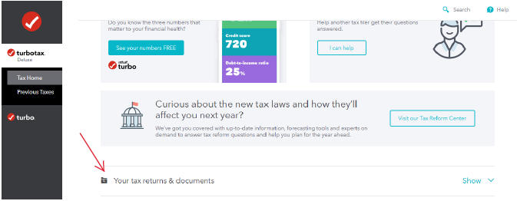

- From Your tax returns & documents, select Amend (change) return.

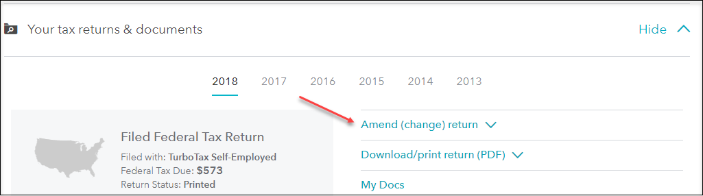

- On the Amend (change) return additional information screen, click the Amend using TurboTax Online button.
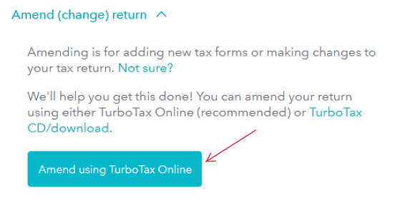

Start to Amend Your Return:
- On the OK, let’s get a kickstart on your 2018 amended return screen, select TurboTax sent me an email. Then, click Continue.

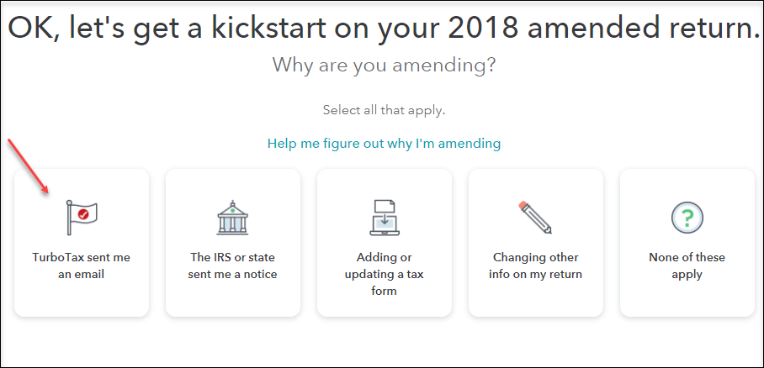

- On the What did we contact you about? screen, select Amending my return to fix info. Then, select Continue.

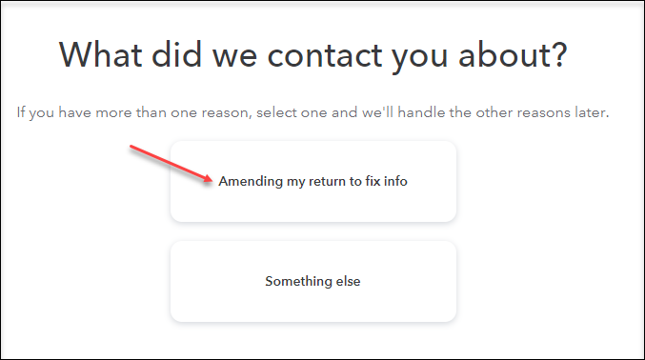

- On the Tell us which 2018 return(s) you want to amend screen, select 2018 Oregon return. Then, select Continue.

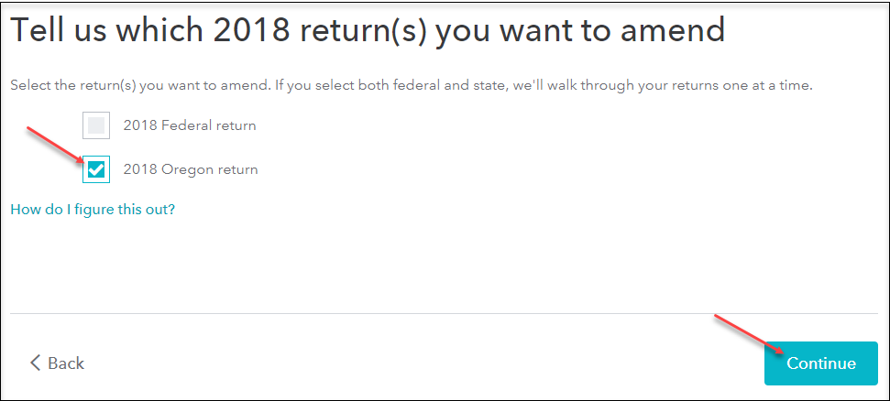

- On the Let’s get started on your state taxes screen, select Continue.
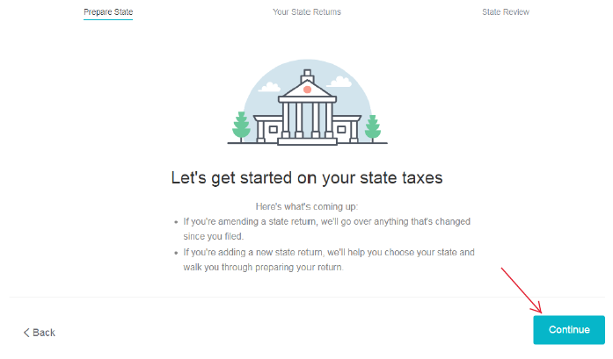
- On the Status of your state returns, next to Oregon select Amend.
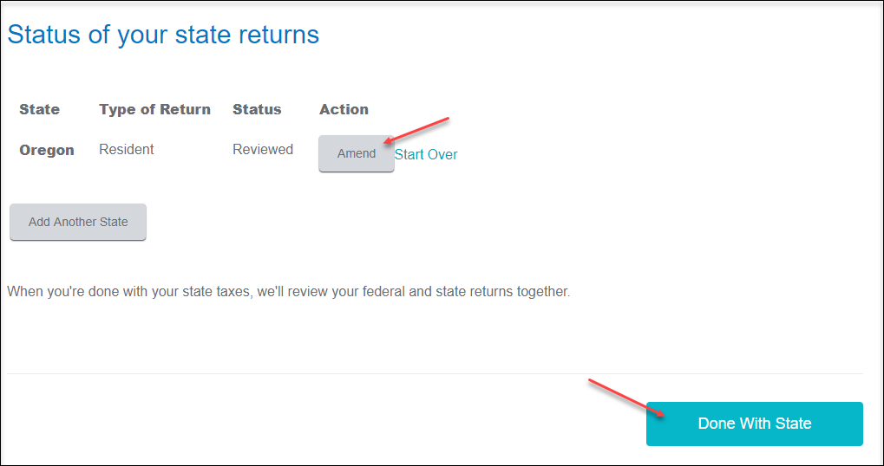

- On the Let’s Amend Your Oregon Return, select Yes, let’s amend and get it done. Then select Continue.

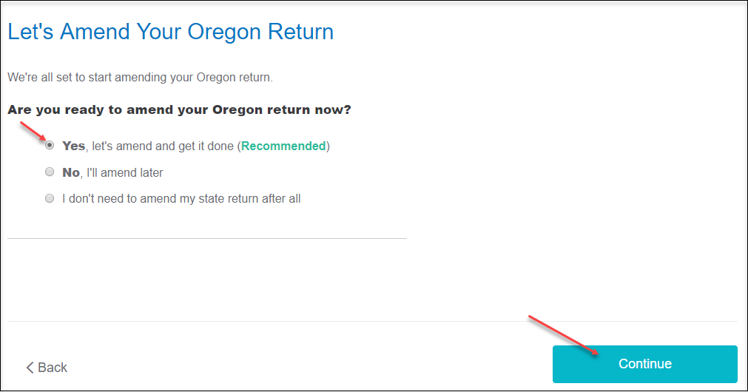
- On the Additional Information, select Continue
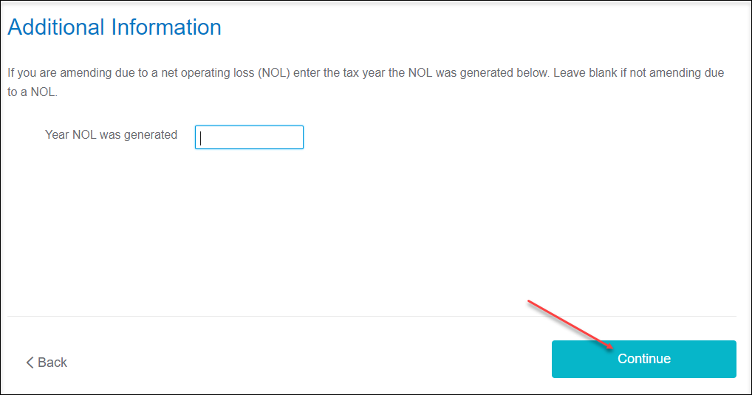

- On the About Your Oregon Amended Return screen, type the following explanation:
“The originally filed Oregon return overstated the amount reported on Schedule OR-A, Itemized Deductions, Line 5, state and local income tax. The amended return corrects the state and local income taxes and correctly reports Oregon income tax due.” Then, select Continue.

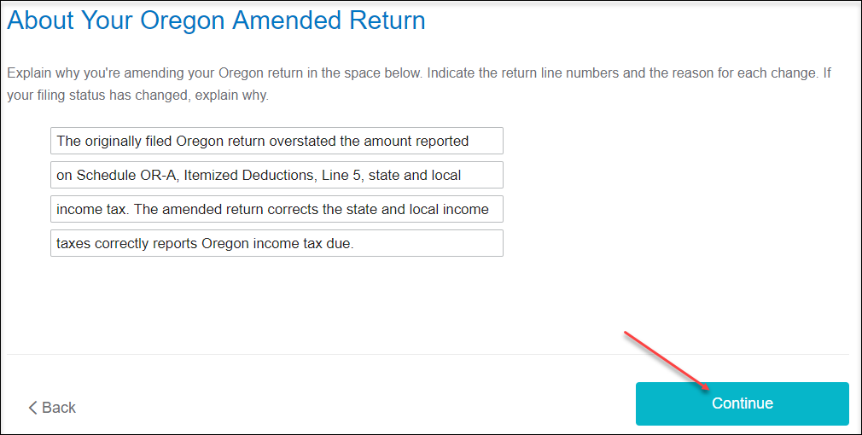

- On the Confirm Your Previous Oregon Refund or Balance Due screen, confirm the amount listed. Then, select Continue. Enter zero, if you had a balance due and did not mail the payment yet.

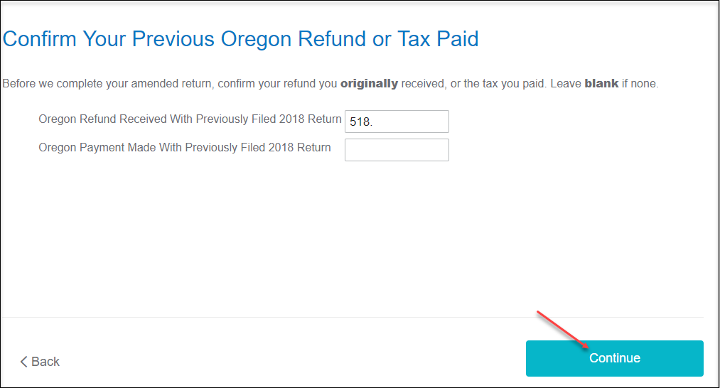

- On the Let’s Make Sure You’re Ready to Review screen, select Yes, I’ve entered everything and let’s review. Then, select Continue.
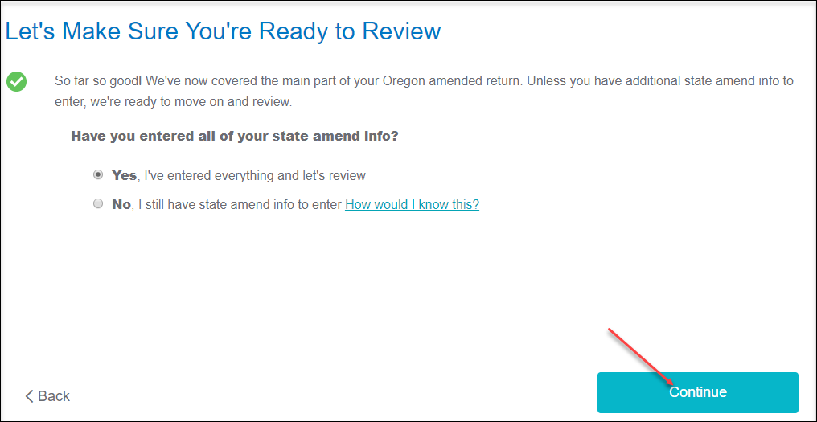

- On the Your 2018 Oregon taxes are ready for us to check screen, scroll to the bottom and select Let’s check it over.

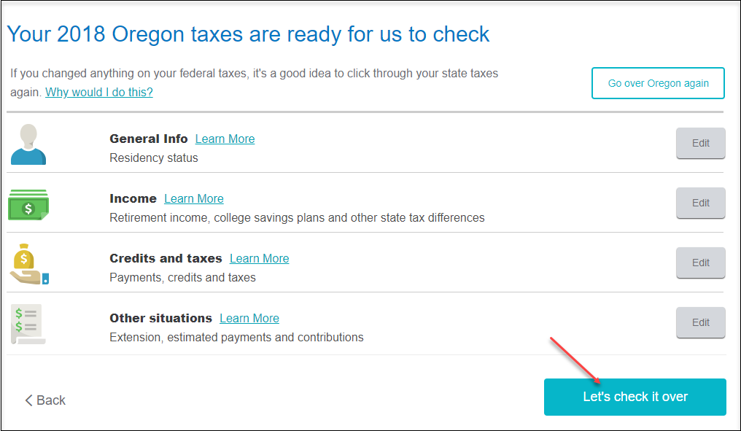

- On the Smart Check Results screen, select Continue

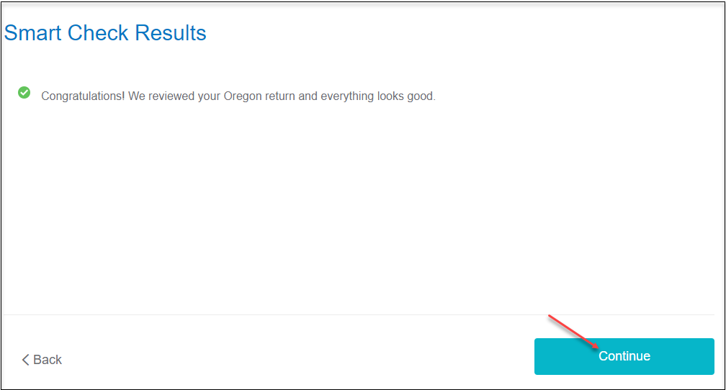

- On the Smart Check Results screen select Continue.

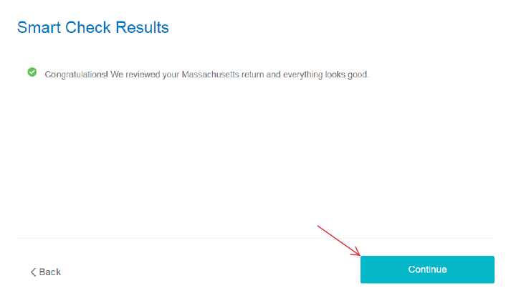

- On the Status of your state returns screen, select Done With State.

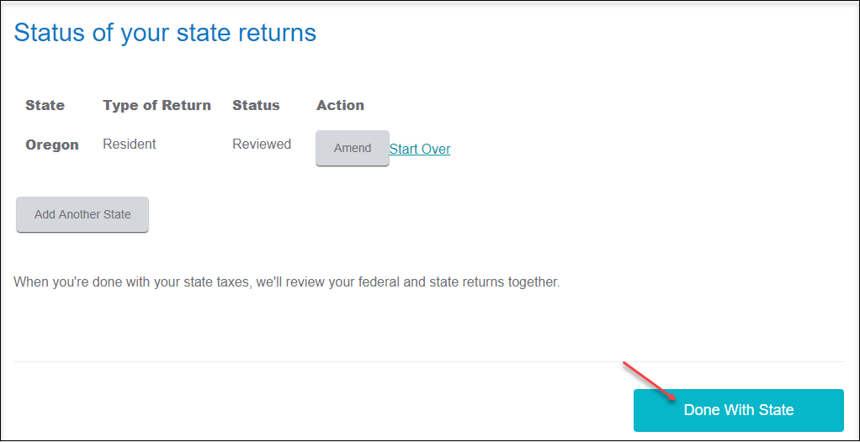

- On the Let’s comb through your returns one last time with complete check screen, select Check my info and complete all final review questions, if any.

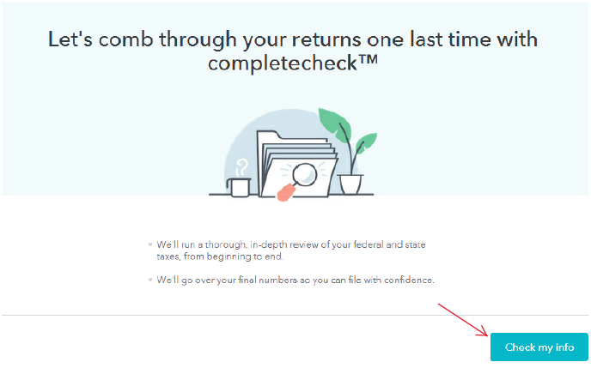

- On the You’re just about ready to file. But first… screen, select Continue.

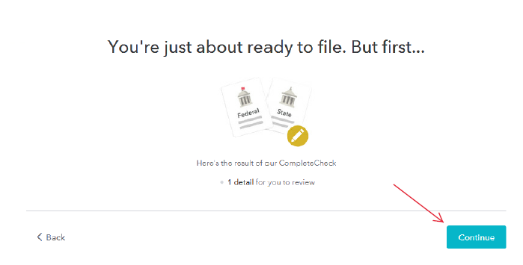

- On the Let’s take care of these details now screen, select Review

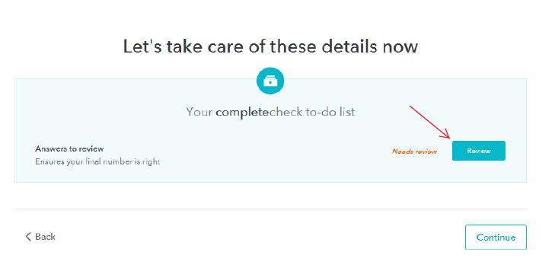

- On the Here are the results of our final review screen, select Fix Oregon Return and complete any final review questions.

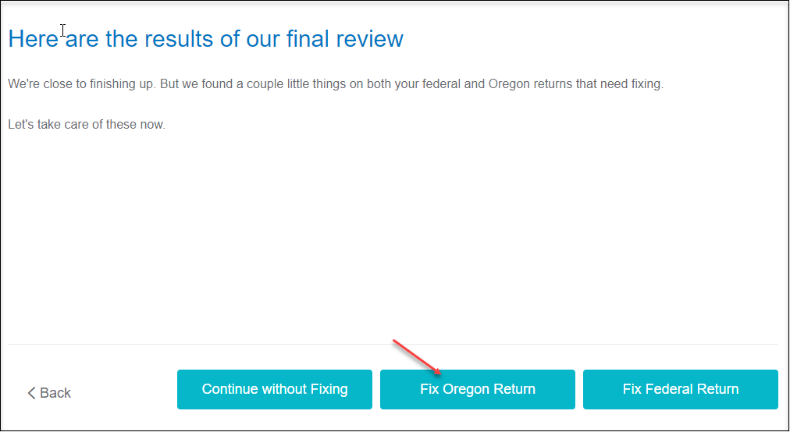

- On the We Won’t Be Able to E-fil Your Return screen, select Continue.

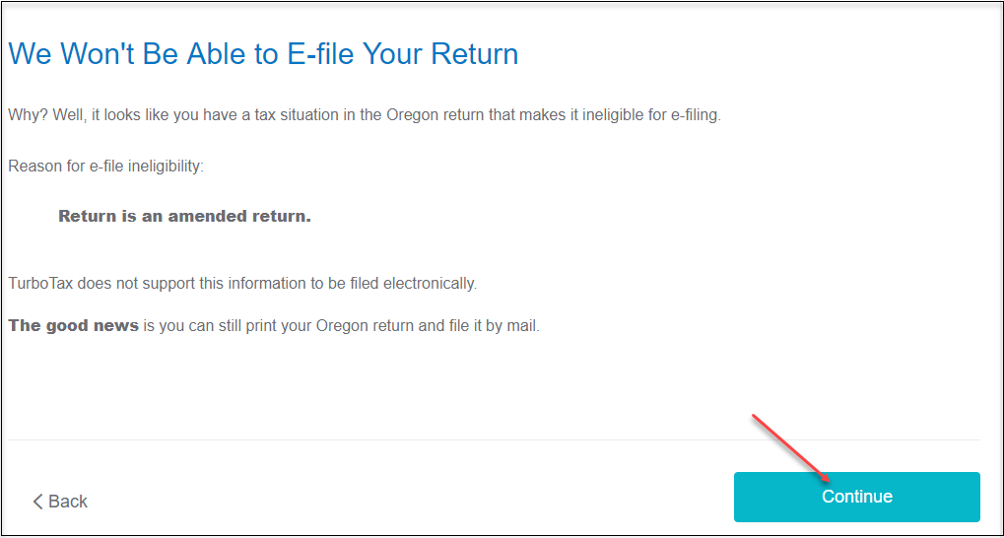

- On the Let’s take care of these details now screen, select Continue.

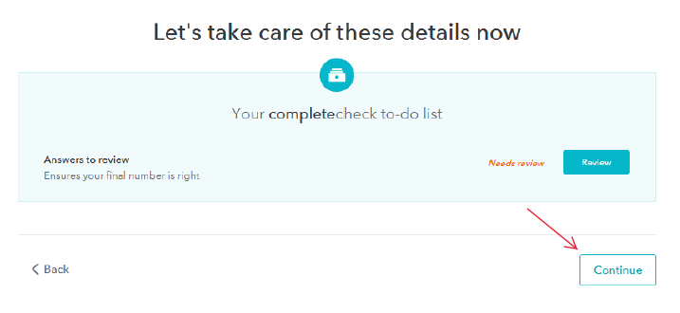

- On the We still have a couple details to button up screen, select Continue.

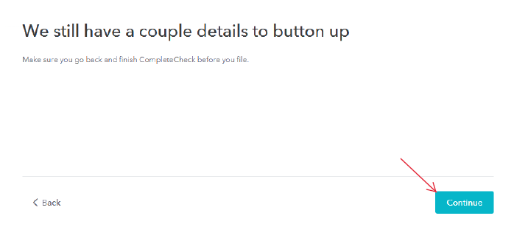

- On the Here are the numbers for your amended return screen, review for the payment to be made. Then, select Continue.

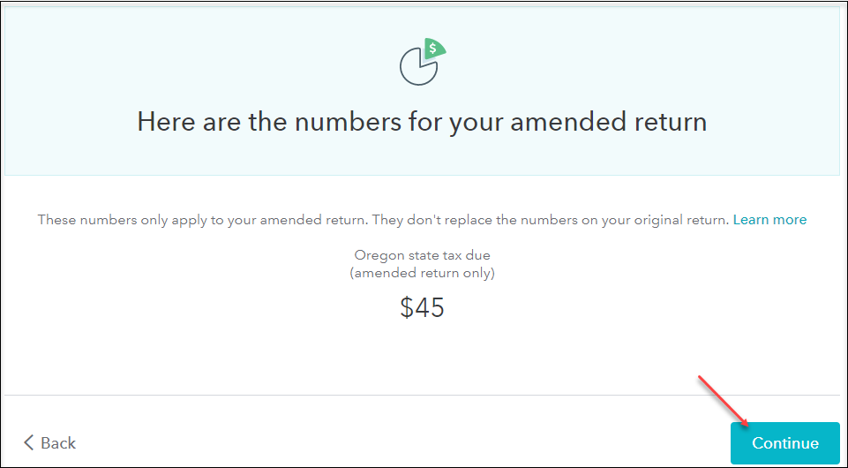

- On the To file your amended returns, you’ll need to print and mail them, select. Continue.

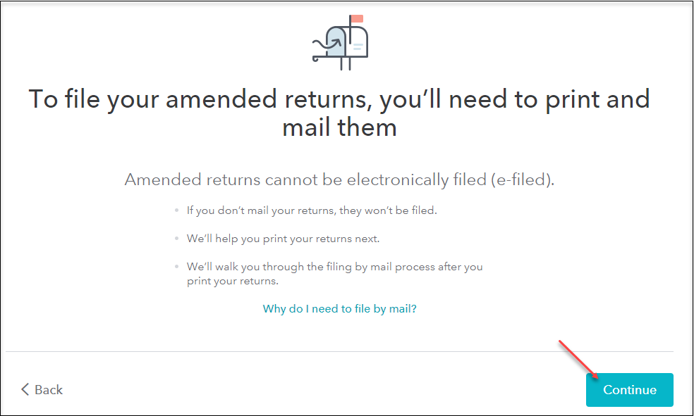

- On the Let’s print your amended return and get ready to file by mail screen, select Print my returns.

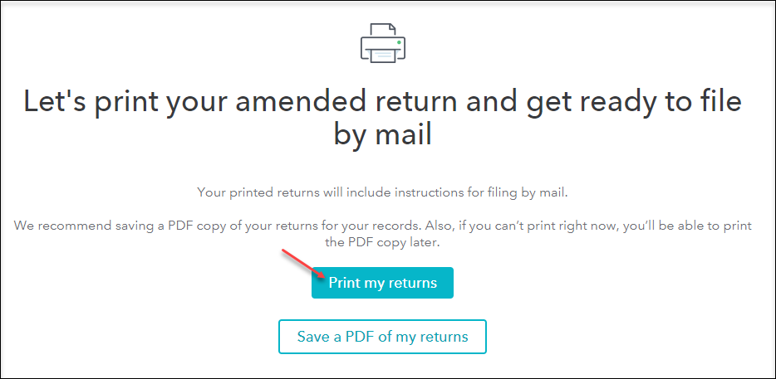

- You are now ready to print your return to file. On the Let’s print your taxes screen, select Download.

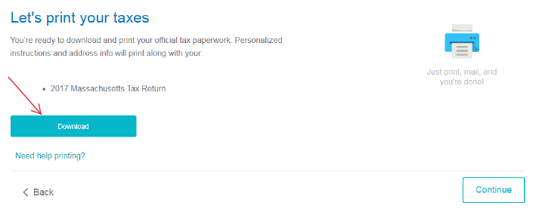

- On the pdf screen that opens, select the Printer Icon to print your forms. You can also select the Download Icon to save a pdf copy of the return to your computer.

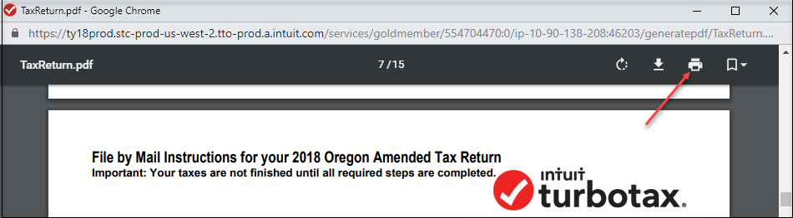

- After printing your return, follow the File by Mail Instructions for your 2018 Oregon Amended Tax Return:
- Mail the amended return along with the balance due to:
Oregon Department of Revenue
P.O. Box 14720
Salem, OR 97309-0463
- Be sure to print out an extra copy to keep for your files.

