2018 Oregon State Amend Instructions for TurboTax CD/Download

- Select and open your return.

- Select File and Save As “Amended 2018 return” before you update TurboTax to preserve your original return.
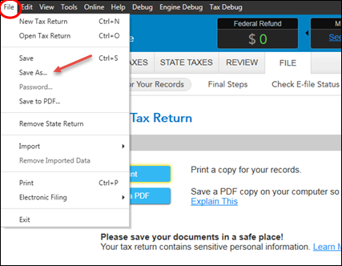

- Select Online and Check for Updates.
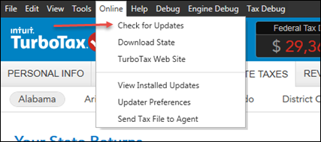

- Go to Federal Taxes tab (if using the Home and Business Product, go to the Personal tab) and then select the Other Tax Situations tab
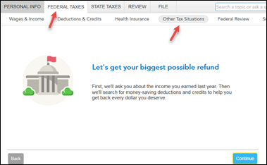

- On the Other Tax Situations screen, scroll down to Other Tax Forms and next to Amend a Return, select the Start button.
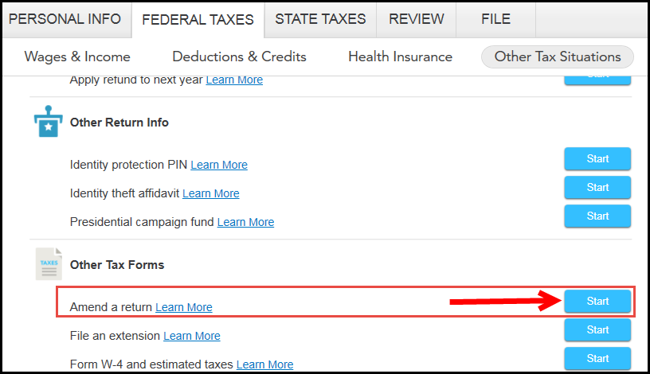

Start to Amend Your Return:
- On the We’ll help you change (amend) your return screen, click Continue.
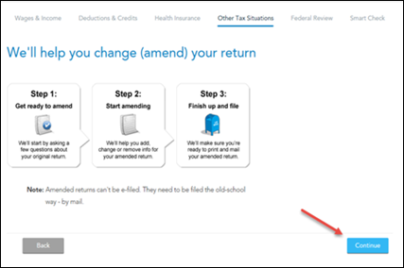

- On the Did you already file your return? screen, select Yes, I’ve already filed my return.
Also select I was contacted by TurboTax and told I may need to amend for some other reason, then click Continue.

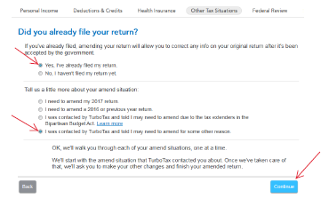

- On the Tell Us Which Returns You Want to Amend screen, select I want to amend only my federal or only my state return. Select Amend my Iowa return. Then select Continue.
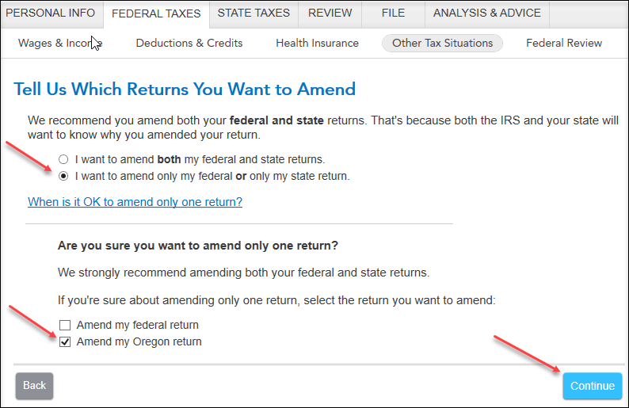

- Scroll to the bottom of the What do you need to change on your return? screen, and select Update next to State Return.

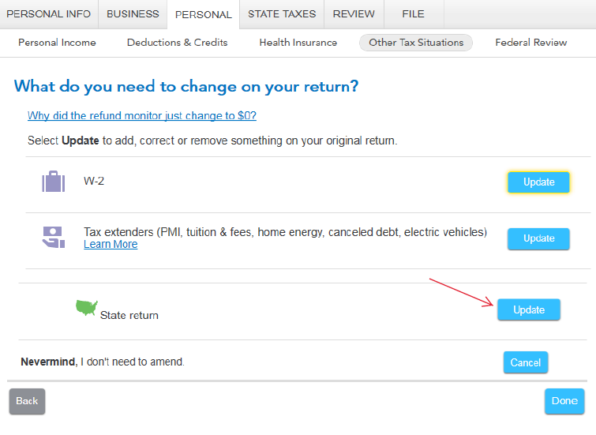

- On the Let’s work on your state return screen, select Continue. Select your Oregon return to Edit. and Continue on the Your 2018 Oregon Return screen.

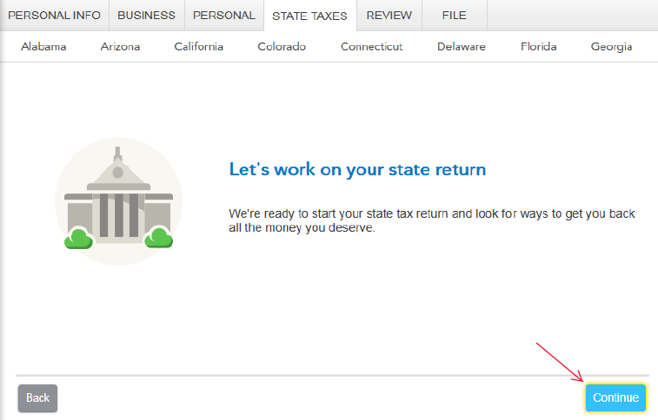

- On the Let’s Amend Your Oregon Return, select Yes, let’s amend and get it done. Then select Continue and Continue on the Additional Information screen.
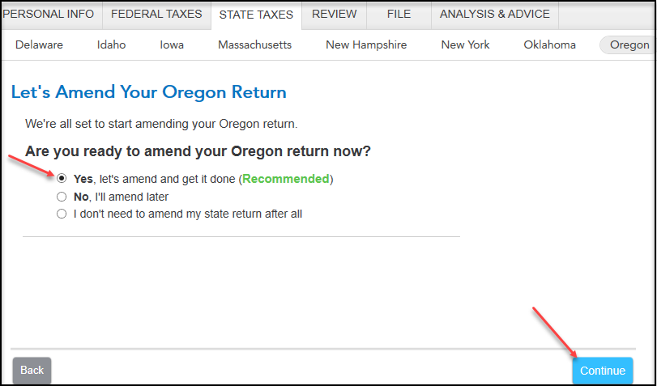

- On the About Your Oregon Amended Return screen, type the following explanation:
“The originally filed Oregon return overstated the amount reported on Schedule OR-A, Itemized Deductions, Line 5, state and local income tax. The amended return corrects the state and local income taxes and correctly reports Oregon income tax due.” Then, select Continue.

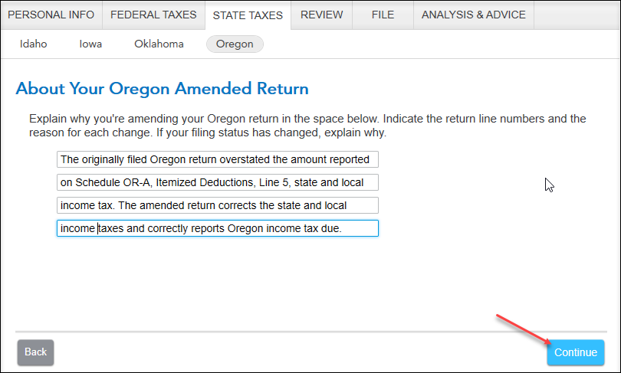

- On the Confirm Your Previous Oregon Refund or Tax Paid screen, confirm the previous refund or payment. Then, select Continue.

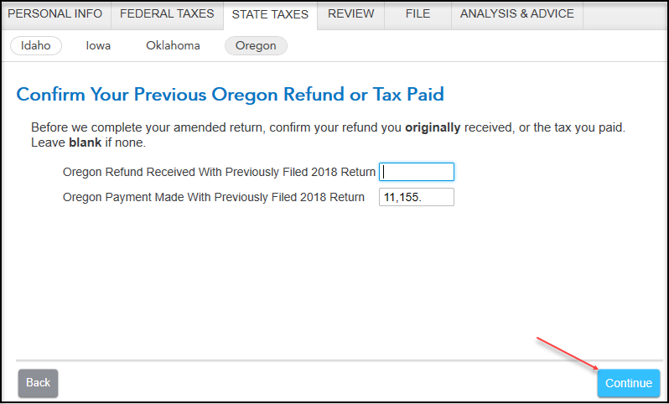

- On the Let’s Make Sure You’re Ready to Review screen, select Yes, I’ve entered everything and let’s review. Then, select Continue.

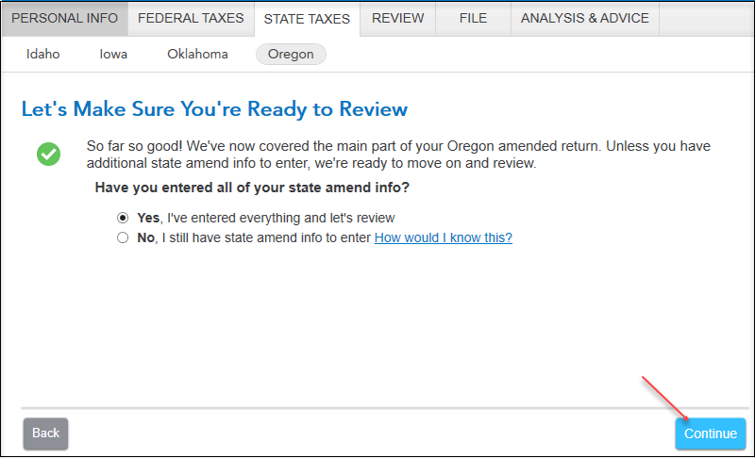

- On the Your 2018 Oregon taxes are ready for us to check screen, select Let’s check it over. and complete all final state review questions, if any.

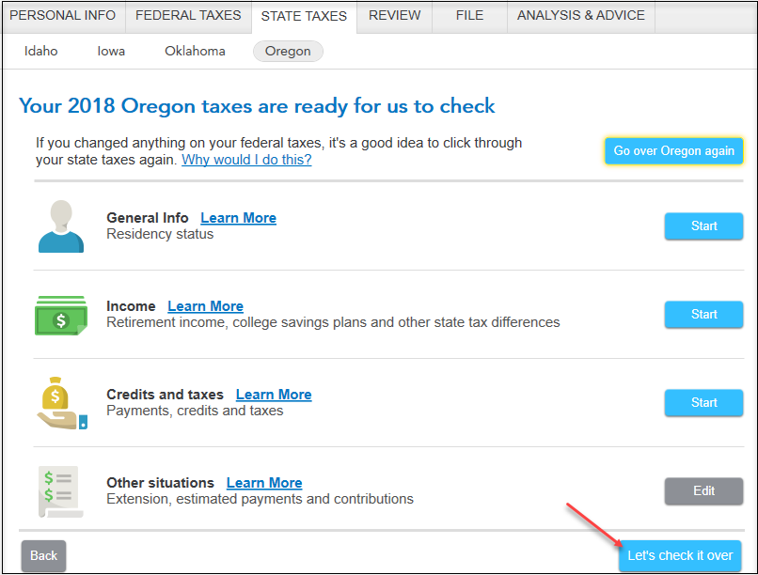

- On the Smart Check Complete screen, select Continue.

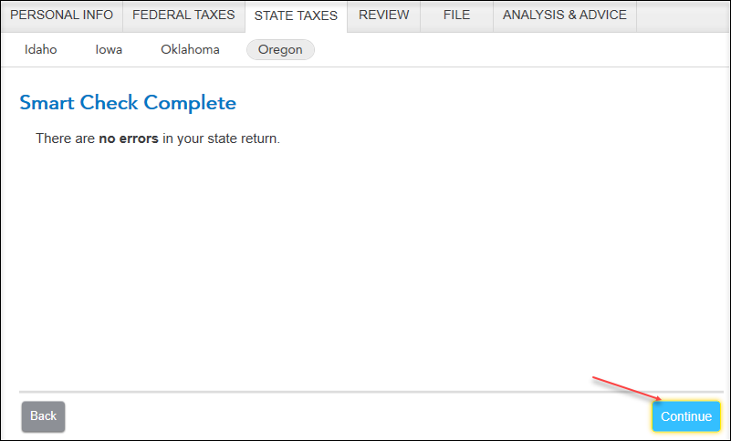
- On the You’re Done with 2018 Oregon screen, select Done With States.
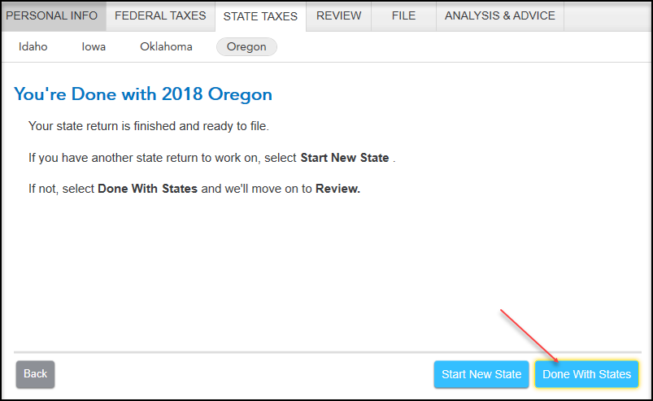

- On the Let’s make sure your taxes are correct screen, select Continue.

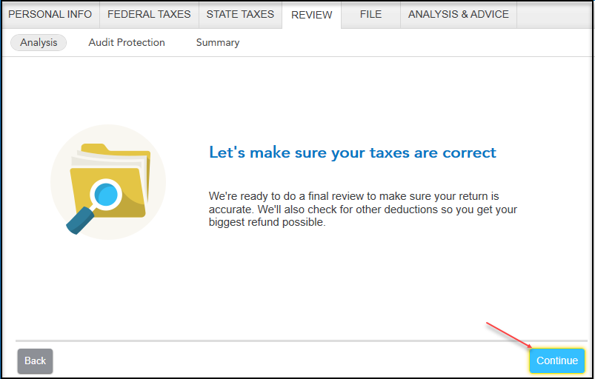

- On the Let’s Check These Entries screen, select Check Entries

- On the We Won’t Be Able to E-file Your Return screen, select Continue.
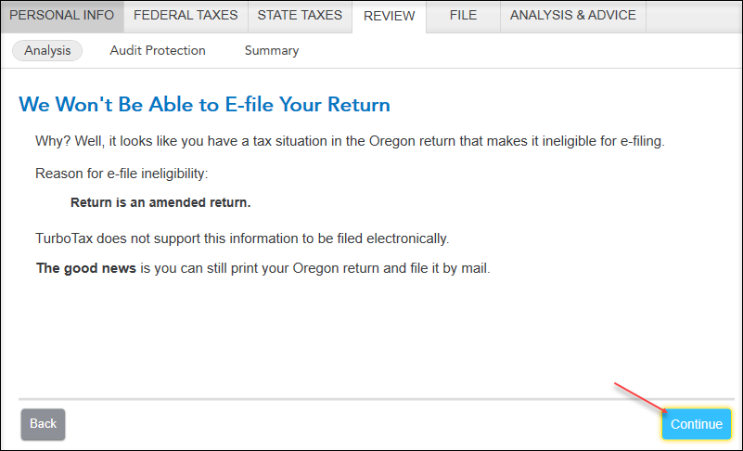
- On the Run State Review Again screen, select Done with Review.

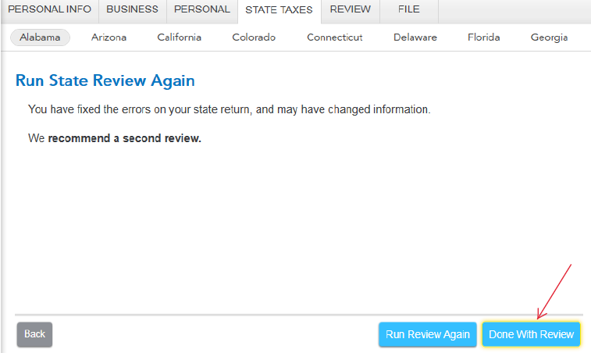

- You are now ready to print your return to file. On the You’re Done! Print and Mail Your Returns screen, select Print Return.

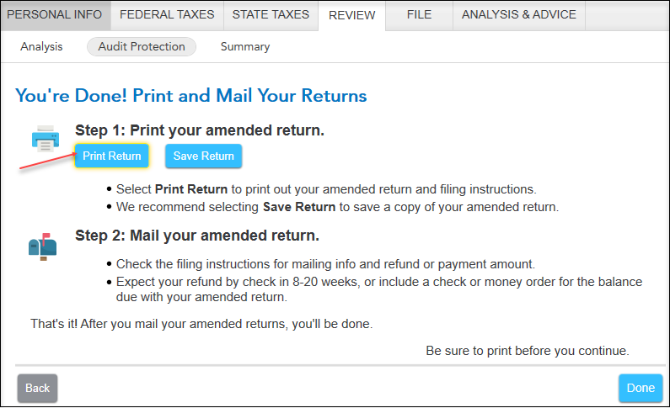
- On the Form Selection window, select All official forms required for filing, check the box for your Oregon return. Then, select Preview Print Copy.

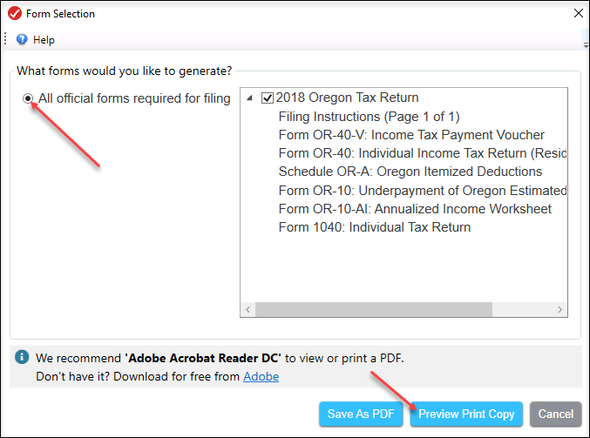

- On the Print Preview screen, select the Printer Icon to print your forms.

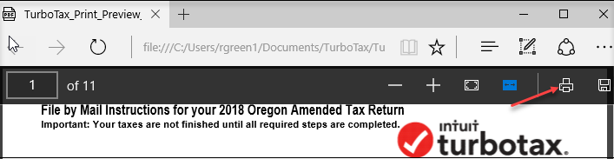

- After printing your return, follow the File by Mail Instructions for you 2018 Oregon Amended Tax Return:
- Mail the amended return along with the balance due to:
Oregon Department of Revenue
P.O. Box 14720
Salem, OR 97309-0463
- Be sure to print out an extra copy to keep for your files.

